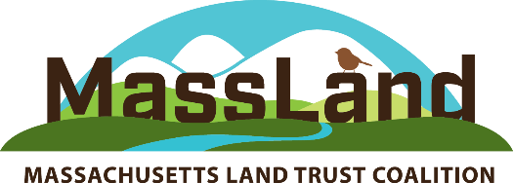

Steering Committee Agenda DRAFT
Wednesday, September 23, 2020 10:00 AM – 12:15 PM
via Zoom
(*advance registration is required)

10:00 Call to Order& Chair Report -- Kathy Orlando, Steering Committee Chair
- Welcome, zoom housekeeping and poll
- Introductions
- Review of Minutes (available to members at http://massland.org/steering-committee)
- Next meeting: Friday Dec 11, 10 AM (via Zoom)
- Setting dates for 2021 (typically March, June, September, December)

10:20 Staff Report MLTC Update – Robb Johnson
- Membership renewal – reminder and thanks!
- Program update: Record-Keeping Initiative and Stronger Together Series
- 2021 Massachusetts Land Conservation Conference – plans taking shape!
- Coming soon: New Job Board on MLTC website
- LTA updates
- Insurance programs for land trusts

10:35 State Agency Updates – Bob O’Connor
- Grants and other agency news, CR reviews, RLI status

10:50 Subcommittee and Working Group Updates
- Conservation Restriction Working Group – Rob Warren
- Valuing Nature’s Services Working Group - Christa Collins
- Amicus Committee -Buzz Constable
- Agricultural Subcommittee – Kathy Orlando
- YLP – Nick Rossi
- Policy Committee – Kristen Sykes

11:10 5 min Break

11:15: Featured Discussion: Linda Orel, with Special Guest Rep. Joan Meschino (D- 3th Plymouth)
- Status of legislation, budget and policy matters in this extended state legislative session
- Details on the 2050 Roadmap bill sponsored by Rep. Meschino, including key amendments on natural and working lands, environmental justice and solar siting. Now in Conference Committee, this bill establishes a framework for the Commonwealth’s response to the climate crisis by adopting the science-based goal of net-zero greenhouse gas emissions by mid-century.
12:10 Announcements - Kathy Orlando

12:15 Adjourn

